FSL_Flanker_task

# 

<https://andysbrainbook.readthedocs.io/en/latest/fMRI_Short_Course/fMRI_01_DataDownload.html>

# **fMRI Tutorial #1: Downloading the Data**

## **Overview**

For this course we will be analyzing an fMRI dataset that used the Flanker task. The dataset can be found [here](https://openneuro.org/datasets/ds000102/versions/00001) on the [OpenNeuro](https://openneuro.org/) website, an online repository for neuroimaging data. (In case the download link on that webpage doesn’t work, go [here](https://legacy.openfmri.org/dataset/ds000102/) and click on the “all data for subjects” link.)

Para este curso analizaremos un conjunto de datos de resonancia magnética funcional que utilizó la tarea Flanker. El conjunto de datos se puede encontrar aquí en el sitio web de OpenNeuro, un depósito en línea de datos de neuroimagen. (En caso de que el enlace de descarga en esa página web no funcione, vaya aquí y haga clic en el enlace "todos los datos de los sujetos").

*The OpenNeuro page for the Flanker dataset includes a Dataset File Tree, which includes the folders anat (containing the anatomical image) and func (containing the functional images and onset times for each run). There are additional files containing subject data such as sex and age (participants.tsv) and scanning parameters (task-flanker_bold.json). A standardized directory tree such as this makes scripting much easier, as we will see in a later tutorial.*

*La página OpenNeuro para el conjunto de datos Flanker incluye un árbol de archivos del conjunto de datos, que incluye las carpetas anat (que contiene la imagen anatómica) y func (que contiene las imágenes funcionales y los tiempos de inicio de cada ejecución). Hay archivos adicionales que contienen datos del sujeto, como sexo y edad (participants.tsv) y parámetros de escaneo (task-flanker_bold.json). Un árbol de directorios estandarizado como este facilita mucho la creación de scripts, como veremos en un tutorial posterior.*

Download the dataset by clicking on the “Download” button at the top of the page. The dataset is about 2 Gigabytes, and comes in a zipped folder. Extract it by double-clicking on the folder, and then move it to your Desktop.

# **fMRI Tutorial #2: Overview of The Flanker Task**

The dataset you downloaded uses the Flanker task, which is designed to tap into a mental process known as cognitive control. For this course, we’re going to define cognitive control as the ability to ignore irrelevant stimuli in order to do the task correctly.

El conjunto de datos que descargó utiliza la tarea Flanker, que está diseñada para aprovechar un proceso mental conocido como control cognitivo. Para este curso, definiremos el control cognitivo como la capacidad de ignorar estímulos irrelevantes para realizar la tarea correctamente.

In the Flanker task, arrows point either to the left or the right, and the subject is instructed to press one of two buttons indicating the direction of the arrow in the middle. If it’s pointing to the left, the subject presses the “left” button; if it’s pointing to the right, the subject presses the “right” button. The middle arrow is flanked by other arrows which either point in the same direction as the middle arrow, or point in the opposite direction from the middle arrow.

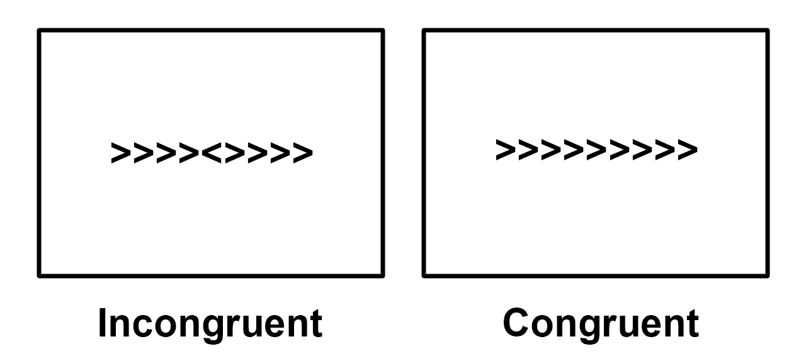

*An example of the two conditions of the Flanker task. In the Incongruent condition, the central arrow (which the subject is focusing on) points in the opposite direction as the flanking arrows; in the Congruent condition, the central arrow points in the same direction as the flanking arrows. In this example the correct response in the Incongruent condition would be to push the “left” button, and the correct response in the Congruent condition would be to push the “right” button. To run through a version of the Flanker task yourself, click* [*here*](http://cognitivefun.net/test/6)*.*

You can imagine that the task is easier if the central arrow points in the same direction as the flanking arrow, and more difficult if it points in the opposite direction. We’ll call the former condition the “Congruent” condition and the latter the “Incongruent” condition. Subjects are typically slower and less accurate in the Incongruent condition, and faster and more accurate in the Congruent condition. Since the difference in reaction times is robust and reliable, it follows that in our fMRI data we should see a noticeable difference in the [BOLD signal](https://andysbrainbook.readthedocs.io/en/latest/glossary/terms/BOLD_Response.html#bold-response) as well.

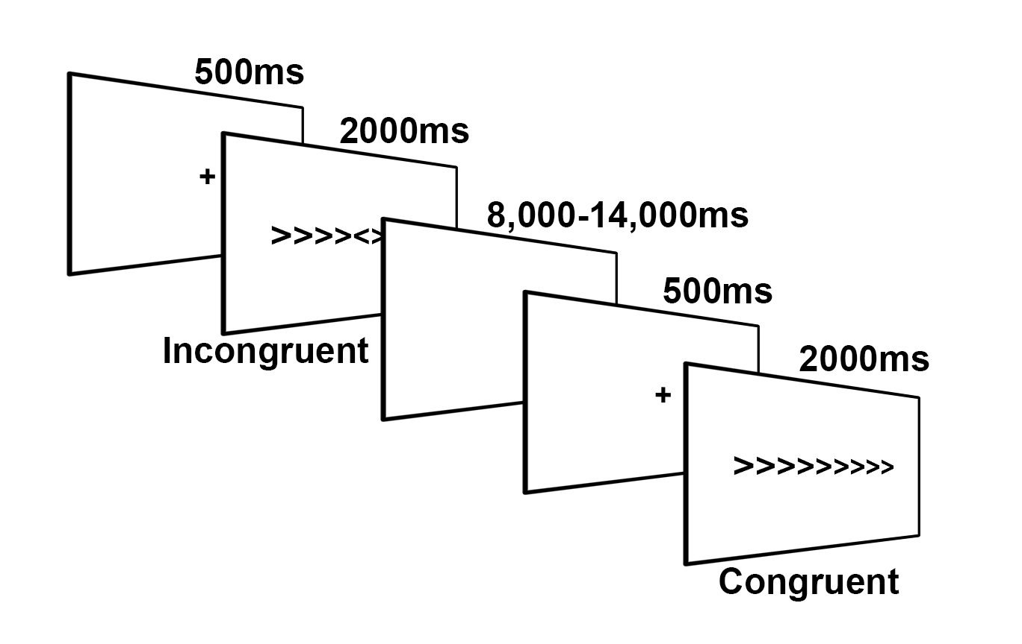

*Illustration of the Flanker task for this study, adapted from Kelly et al. (2008). The subject is shown a fixation cross in order to focus on the center of the screen, and then either a Congruent or Incongruent Flanker trial is presented for 2000ms. During the trial the subject presses either the left or right button. A jittered interval follows which lasts anywhere from 8,000ms to 14,000ms. (Note that jittered intervals typically increment in seconds; in this case, the jitter for a given trial would be a random selection of one of the following: 8,000ms, 9,000ms, 10,000ms, 11,000ms, 12,000ms, 13,000ms, and 14,000ms) Another fixation cross is presented to begin the next trial.*

Our goal is to estimate the magnitude of the BOLD signal to each condition, and then **contrast** (i.e., take the difference of) the two conditions to see whether they are significantly different from each other.

**Note**

This description of the task brings up an important point about good practice for designing fMRI studies: If you can design a behavioral task that produces a strong and reliable effect, you will increase your odds of finding an effect in your imaging data. fMRI data is notoriously noisy - if you don’t see a behavioral effect in your study, you most likely will not find an effect in your imaging data either.

# **fMRI Tutorial #3: Looking at the Data**

## **Overview**

Now that you’ve downloaded the dataset, let’s see what it looks like. If the dataset has been downloaded to your Downloads directory, navigate to the Desktop and type the following:

mv ~/Downloads/ds000102_0001/ Flanker

Which will rename the folder to Flanker and put it on your Desktop.

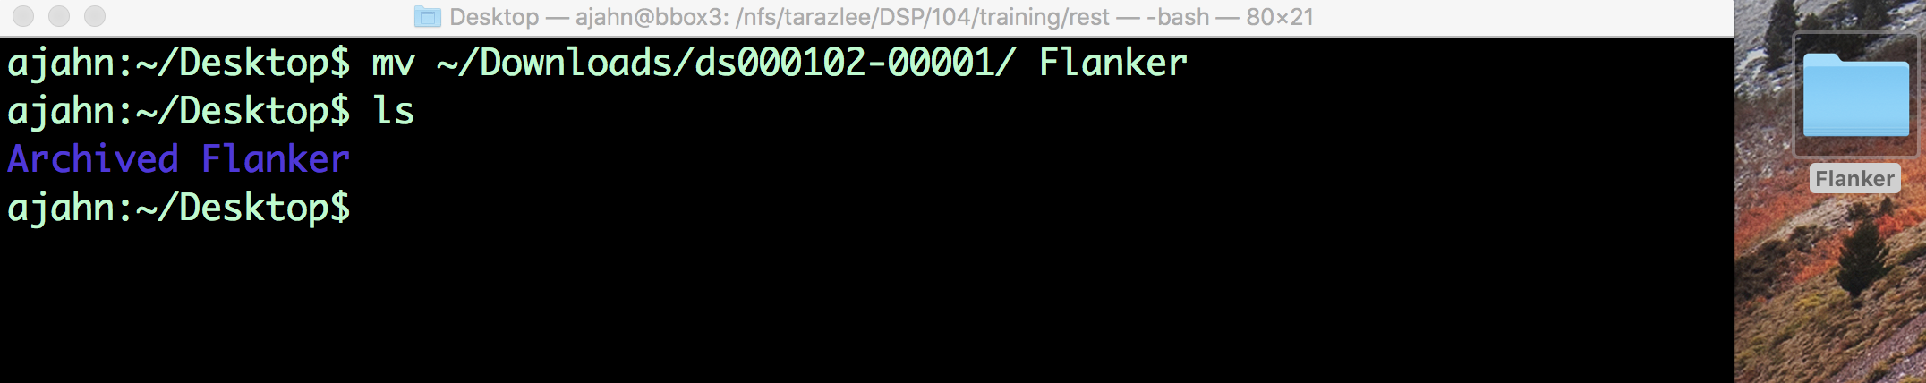

*After downloading the Flanker dataset, type the command above to move it to your Desktop.*

As you saw in the previous [Data Download page](https://andysbrainbook.readthedocs.io/en/latest/fMRI_Short_Course/fMRI_01_DataDownload.html#fmri-01-datadownload), the dataset has a standardized structure: Each subject folder contains an anatomical directory and a functional directory labeled anat and func, and these in turn contain the anatomical and functional images, respectively. (The func directory also contains **onset times**, or timestamps for when the subject underwent either a Congruent or Incongruent trial.) This format is known as [BIDS](http://bids.neuroimaging.io/), or Brain Imaging Data Structure, which makes it easy to organize and find your data.

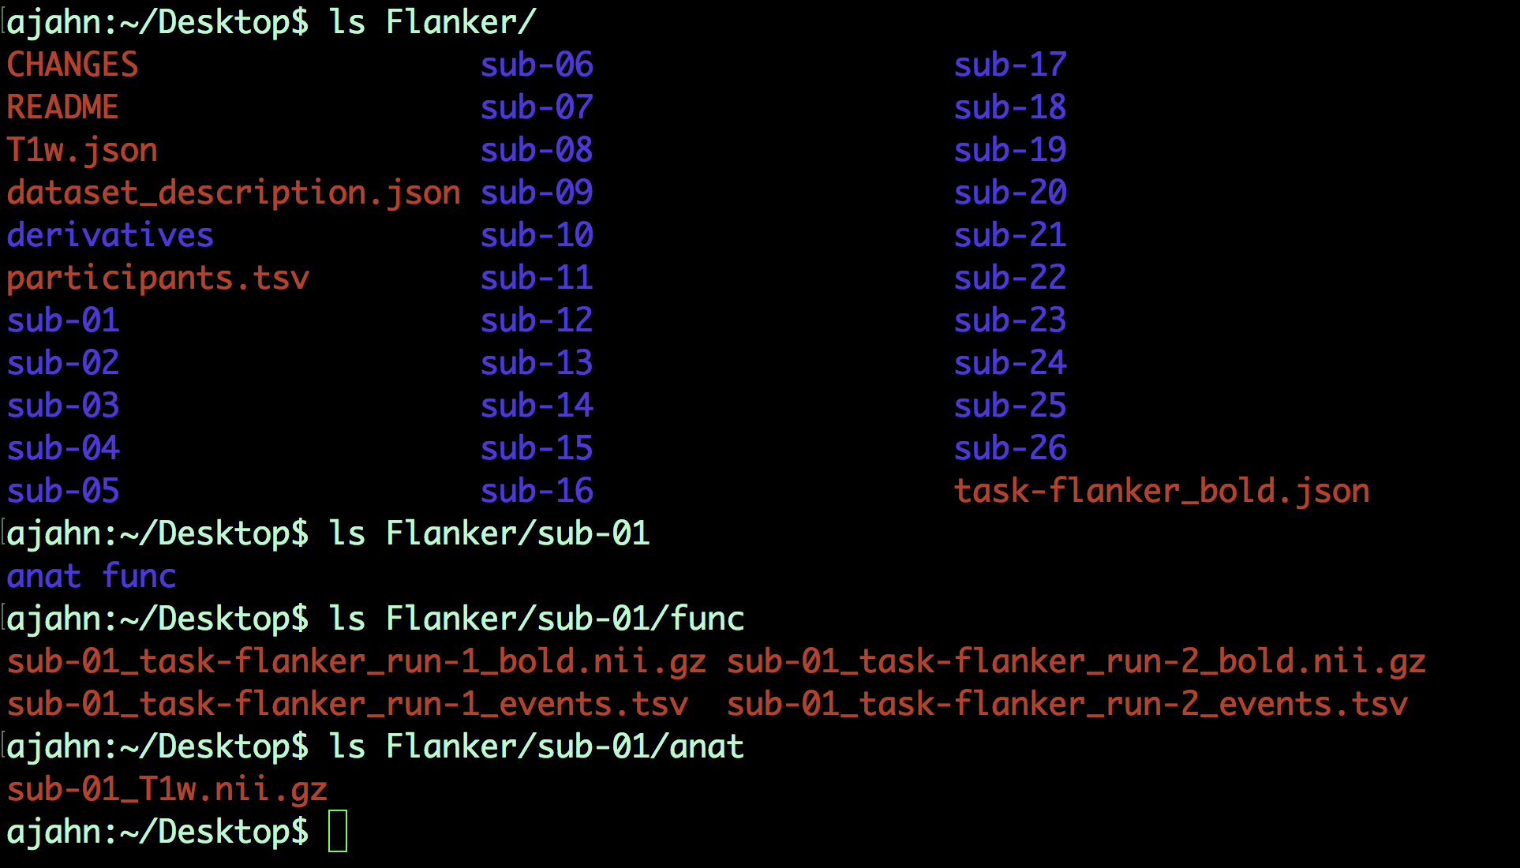

*Example of the BIDS format. Note that the func directory contains functional data - in this case, two runs of functional data - and corresponding “events.tsv” files, which contain* ***onsets****, or timestamps of which condition happened at what time. You can open these as a text file or as a spreadsheet.*

## **Inspecting the Anatomical Image**

Whenever you download imaging data, check the anatomical and functional images to inspect them for any problems - scanner spikes, incorrect orientation, poor contrast, and so on. It will take some time to develop an eye for what these problems look like, but with practice it will become quicker and easier to do.

Let’s take a look at the anatomical image in the anat folder for sub-08. Navigate to the sub-08 folder and then type

fsleyes anat/sub-08_T1w.nii.gz

This will open the anatomical image in fsleyes, FSL’s image viewer.

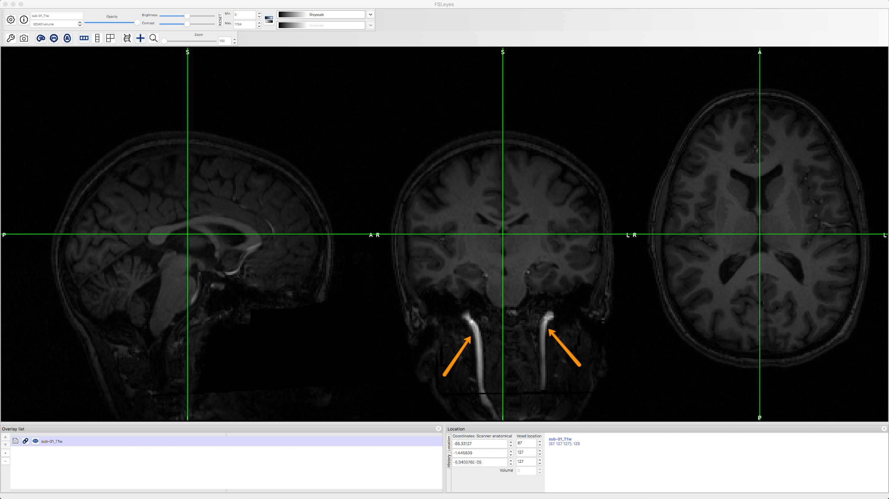

*The anatomical image displayed in fsleyes. The contrast seems low between the grey and white matter, but this is because the blood vessels of the neck (indicated by orange arrows) are much brighter than the rest of the brain.*

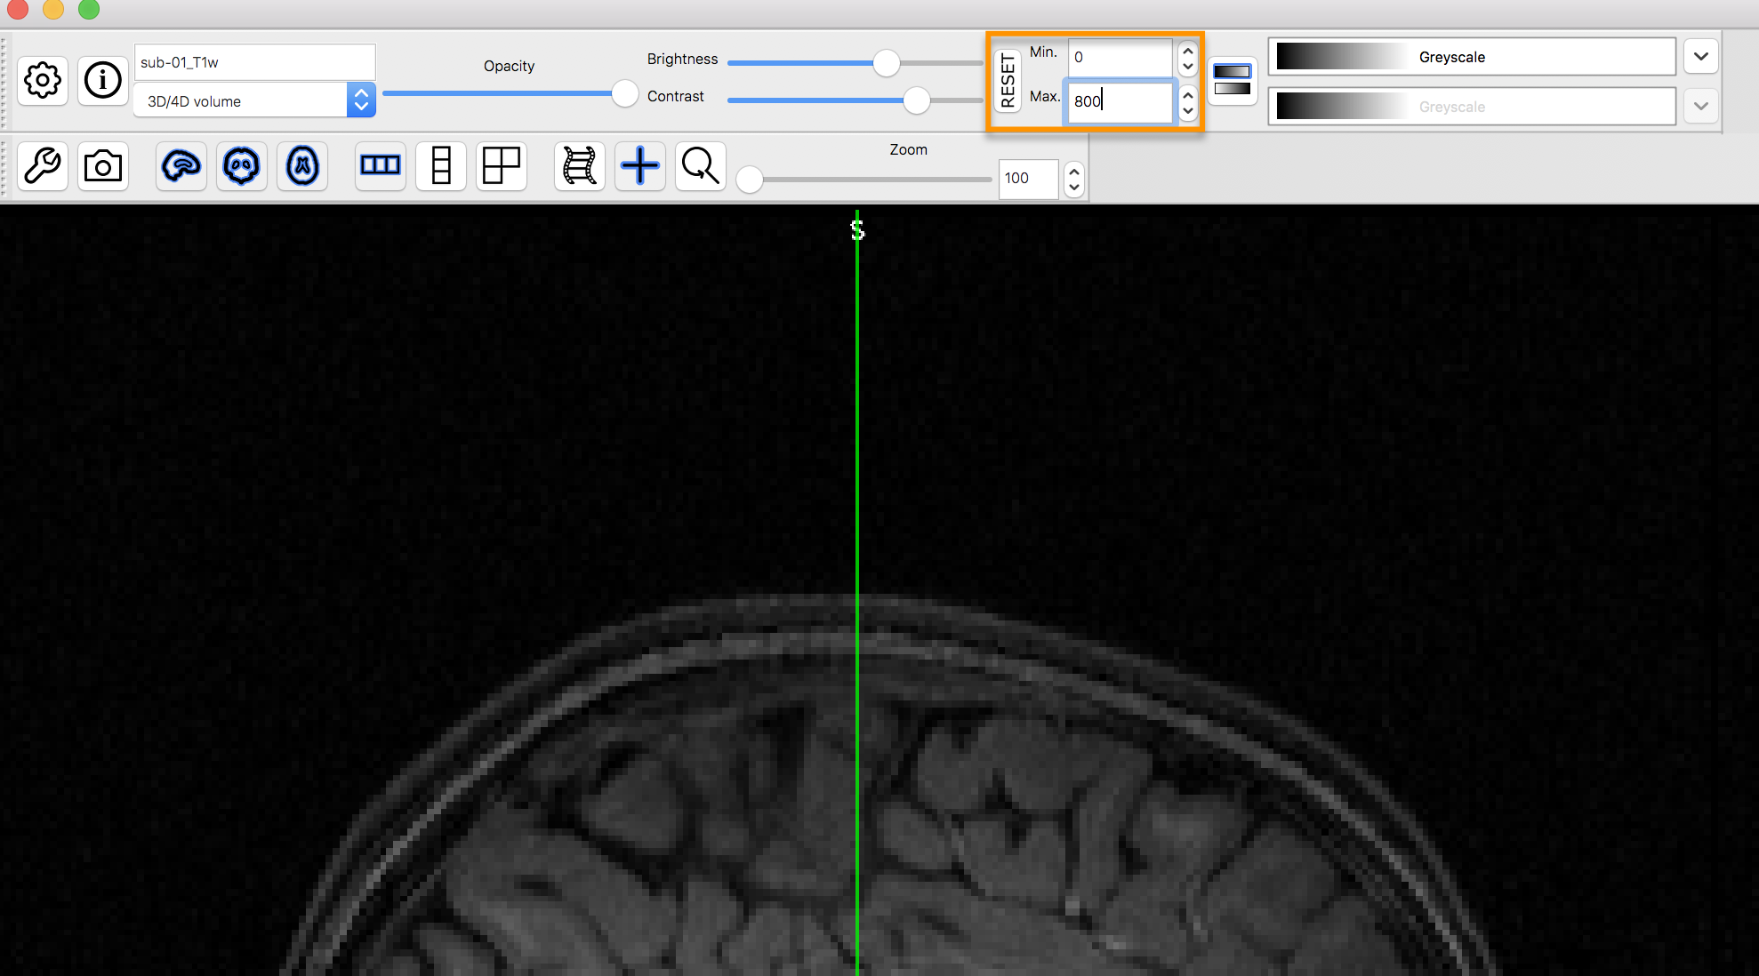

*This can be fixed by changing the numbers in the contrast box. Here, the Maximum has been lowered to 800, capping the brightest signal at that value. This makes it easier to see the contrast between the tissues.*

Inspect the image by clicking and dragging the mouse around. You can switch viewing panes by clicking in the corresponding window. Note that the other windows are updated in real time as you move your mouse around. This is because MRI data is collected as a three-dimensional image, and moving along one of the dimensions will change the other windows as well.

**Note**

You may have noticed that this subject appears to be missing his face. That is because the data from OpenNeuro.org have been **deidentified**: Not only has information such as name and date of scanning been removed from the header, but the faces have also been erased. This is done in order to ensure the subject’s anonymity.

As you continue to inspect the image, here are two things you can watch out for:

1. Lines that look like ripples in a pond. These ripples may be caused by the subject moving too much during the scan, and if the ripples are large enough, they may cause preprocessing steps like brain extraction or normalization to fail.
2. Abnormal intensity differences within the grey or the white matter. These may indicate pathologies such as aneurysms or cavernomas, and they should be reported to your radiologist right away; make sure you are familiar with your laboratory’s protocols for reporting artifacts. For a gallery of pathologies you may see in an MRI image, click [here](http://www.mrishark.com/brain1.html).

## **Inspecting the Functional Images**

When you are done looking at the anatomical image, click on Overlay -> Remove All from the menu at the top of your screen. Then, click on File -> Add from File, navigate to sub-08’s func directory, and select the image ending in run-1_bold.nii.gz. This image also looks like a brain, but it is not as clearly defined as the anatomical image. This is because the **resolution** is lower. It is typical for a study to collect a high-resolution T1-weighted (i.e., anatomical) image, and lower-resolution functional images, in part because we collect the functional images much more quickly.

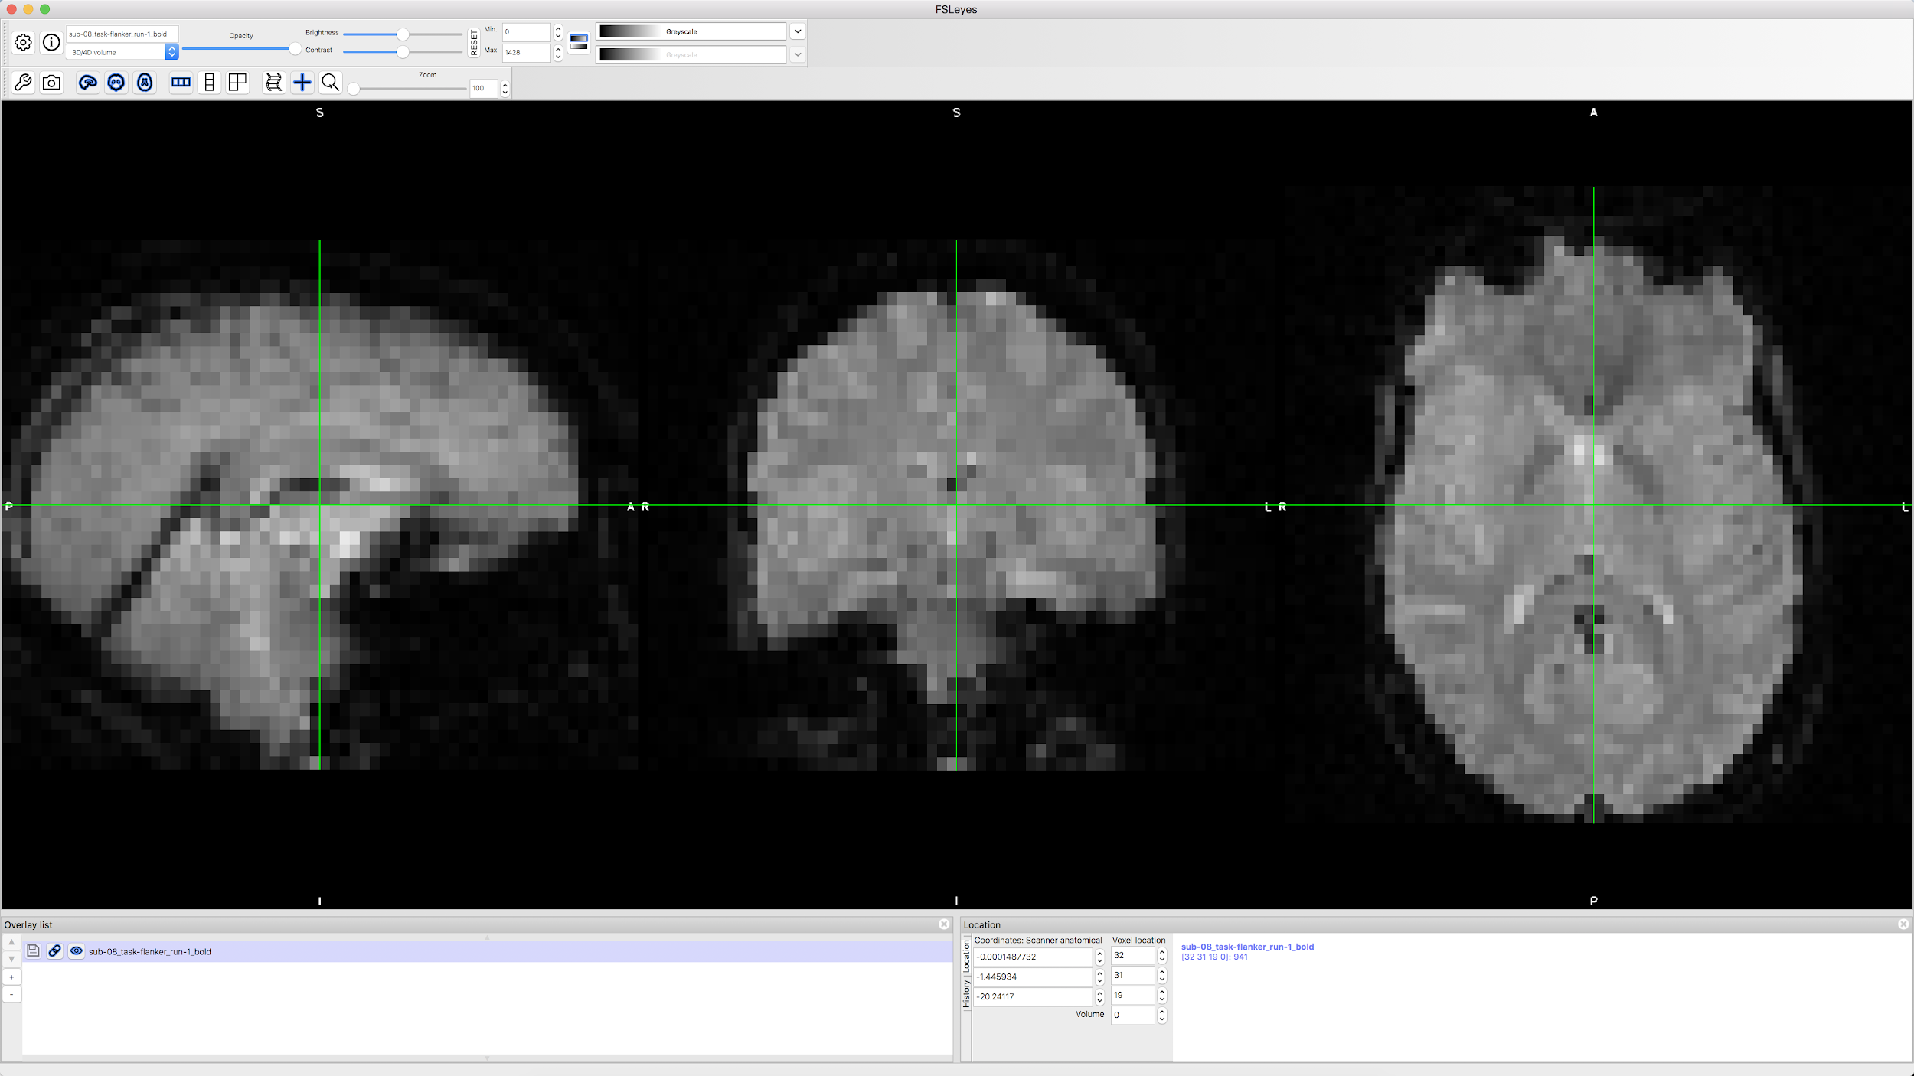

Many of the quality checks for the functional image are the same as with the anatomical image: Watch out for extremely bright or extremely dark spots in the grey or white matter, as well as for image distortions such as abnormal stretching or warping. One place where it is common to see a little bit of distortion is in the orbitofrontal part of the brain, just above the eyeballs. There are ways to reduce this distortion, but for now we will ignore it.

Another quality check is to make sure there isn’t excessive motion. Functional images are often collected as a time-series; that is, multiple volumes are concatenated together into a single dataset. You can rapidly flip through all of the volumes like pages of a book by clicking on the movie reel icon in fsleyes. Note any sudden, jerky movements in any of the viewing panes. During preprocessing, we will quantify how much motion there was in order to decide whether to keep or to discard that subject’s data.

## **Video**

Follow along [here](https://www.youtube.com/watch?v=eRDat10yGSs) for a demonstration of quality checking fMRI data. When you are finished, click on the Next button to learn about preprocessing the data.

# **fMRI Tutorial #4: Preprocessing**

**Note**

Many of the examples are run from the Flanker/sub-08 directory; I recommend navigating to that directory with your Terminal before reading the rest of the chapter.

## **Overview**

Now that we know where our data is and what it looks like, we will do the first step of fMRI analysis: **Preprocessing**.

Think of preprocessing as cleaning up the images. When you take a photo with a camera, for example, there are several things you can do to make the image look better:

* Remove red eye;
* Increase color saturation;
* Remove shadows.



*A picture we take with a camera may be dark, blurry, or noisy (left panel). After editing the image by enhancing contrast, reducing blur, and increasing brightness, we end up with a more defined and clearer picture.*

Similarly, when we preprocess fMRI data we are cleaning up the three-dimensional images that we acquire every TR. An fMRI volume contains not only the signal that we are interested in - changes in oxygenated blood - but also fluctuations that we are not interested in, such as head motion, random drifts, breathing, and heartbeats. We call these other fluctuations **noise**, since we want to separate them from the signal that we are interested in. Some of these can be regressed out of the data by modeling them (which is discussed in the chapter on modeling fitting), and others can be reduced or removed by preprocessing.

To begin preprocessing sub-08’s data, read the following descriptions of each step.

**Preprocessing Steps**

* [Chapter 1: Brain Extraction (also known as “skullstripping”)](https://andysbrainbook.readthedocs.io/en/latest/fMRI_Short_Course/Preprocessing/Skull_Stripping.html)
* [Chapter 2: The FEAT GUI and loading the functional data](https://andysbrainbook.readthedocs.io/en/latest/fMRI_Short_Course/Preprocessing/FEAT_GUI.html)
* [Chapter 3: Motion Correction](https://andysbrainbook.readthedocs.io/en/latest/fMRI_Short_Course/Preprocessing/Motion_Correction.html)
* [Chapter 4: Slice-Timing Correction](https://andysbrainbook.readthedocs.io/en/latest/fMRI_Short_Course/Preprocessing/Slice_Timing_Correction.html)
* [Chapter 5: Smoothing](https://andysbrainbook.readthedocs.io/en/latest/fMRI_Short_Course/Preprocessing/Smoothing.html)
* [Chapter 6: Registration and Normalization](https://andysbrainbook.readthedocs.io/en/latest/fMRI_Short_Course/Preprocessing/Registration_Normalization.html)
* [Chapter 7: Checking your Preprocessed Data](https://andysbrainbook.readthedocs.io/en/latest/fMRI_Short_Course/Preprocessing/Checking_Preprocessing.html)
* [Checkpoint: Preprocessing](https://andysbrainbook.readthedocs.io/en/latest/fMRI_Short_Course/Preprocessing/Checkpoint.html)

### **Video**

When you have finished all of the chapters, click [here](https://www.youtube.com/watch?v=VobRXk3ccNQ&list=PLIQIswOrUH6-rpwcmo2ewY2wi4Yoym9ft) for a playlist containing all of the videos used to demonstrate the preprocessing steps.

**Note**

Different software packages will do these steps in slightly different order - for example, FSL will normalize the statistical maps after model fitting. There are also analyses which omit certain steps - for example, some people who do multi-voxel pattern analyses don’t smooth their data. In any case, the list above represents the most common steps that are performed on a typical dataset.

# **Chapter 1: Brain Extraction (also known as “skullstripping”)**

Since fMRI studies focus on brain tissue, our first step is to remove the skull and non-brain areas from the image. FSL has a tool for this called **bet**, or the Brain Extraction Tool. It is the first button listed on the FSL GUI (indicated by “A” in the figure below). If you click on this button, another window opens that allows you to specify the Input image to skullstrip and what to label the Output image that has been skullstripped (B), and an expandable sub-window that allows you to specify advanced options (C).

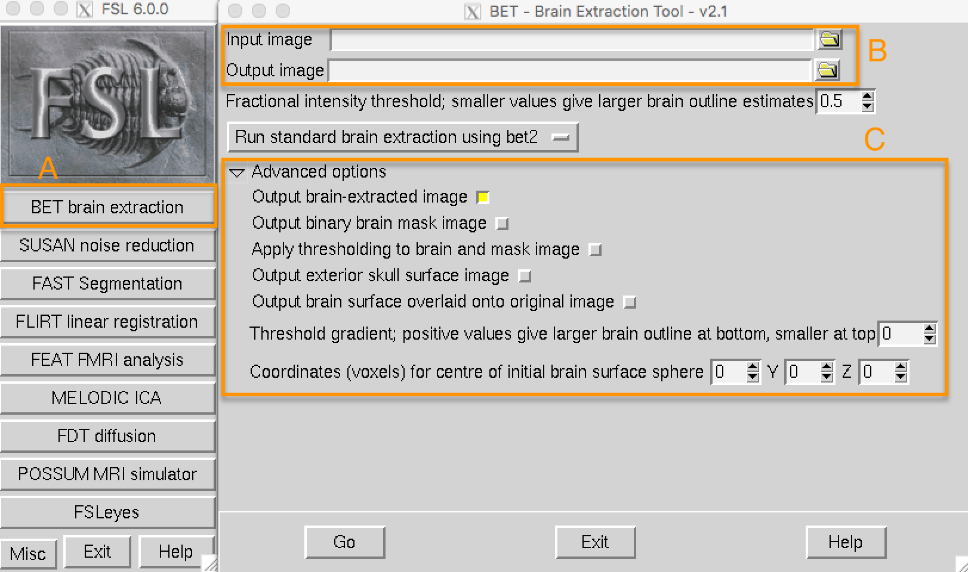

**Note**

For BET and many of the other FSL tools, you are required to specify an input image and a label for the output image: Some operation is performed on the input image (skullstripping, for example) and the output image is the result of that operation. Usually the other options are set to defaults that work well for the majority of datasets, but you can override them if you want.

Open the FSL GUI from the sub-08 directory, click on the Folder icon next to the Input image field, and navigate to the anat directory. Select the file sub-08_T1w.nii.gz and click the OK button. Notice that the Output image field is automatically filled in with the word brain appended to your Input image, which is FSL’s default. You can change the name if you like, but for this tutorial we will leave it as is.

Now click the Go button at the bottom of the window. You will see some text written to your Terminal showing which commands are being used to run a command called bet2. Take a moment to see how the GUI corresponds to the Terminal - later on we will take advantage of this by creating a template through the GUI and then modifying it in the Terminal to automatically preprocess all of the subjects in our dataset.

## **Looking at the data**

When the Terminal says “Finished”, bet2 is done. Since you have created a new image you should **look at your data**, which we will do after each preprocessing step.

**Note**

Newcomers often hear the phrase “Look at your data” intoned like a mantra. Without knowing *how* to look at one’s data, the words become meaningless at best, a false comforter at worst. Each of the preprocessing steps in this chapter will be followed by recommendations of what to look for and concrete examples of what is OK and what is a problem - and what to do about it. Although we cannot cover every possible example, as you gain experience you will develop your judgment of what images are of good quality, and which ones need to be either fixed or removed.

Click on the FSLeyes button at the bottom of the GUI. When it opens, click on File -> Add from File and hold shift to select both the original anatomical image and the skullstripped image you just created. As you saw in a [previous chapter](https://andysbrainbook.readthedocs.io/en/latest/fMRI_Short_Course/fMRI_03_LookingAtTheData.html#fmri-03-lookingatthedata), you will want to change the contrast to clearly distinguish the grey matter from the white matter.

By loading both images you can compare the image before and after the skull was removed. In the Overlay List panel in the lower left corner of FSLeyes, click the “eye” icon to hide the corresponding image. For example, if you click on the eye icon next to sub-08_T1w, the original T1 anatomical image will become invisible, and you will only see the skullstripped brain. If you click on the eye again, you will see the original T1. To make the differences between the brains more apparent, highlight the skullstripped image in the Overlay List panel, then change the contrast from Greyscale to Blue-Light blue. The animation below shows you how to do this.

**Warning**

With the November 2019 release of fsleyes, some users encounter the following error message when they try to load an image generated by any of the FSL commands: “Error loading overlay: Does not look like a BIDS file.” If you get this error message, try moving the .json files in the anat and func directories into a separate folder, and then try to load the images again.

Click around the image with your mouse and observe where there is either too much brain or too little skull that was removed. Remember that we are trying to create an image that has had the skull and face stripped clean away, with only the brain (e.g., cortex, subcortical structures, brainstem, and cerebellum) remaining.



*A demonstration of how to use BET to examine the anatomical image before and after skullstripping. Note that in the frontal cortex, part of the brain has been stripped away. Make sure to check all three viewing panes to see where there are problems.*

## **Fixing a bad skullstrip**

If you’re not happy with the skullstripping, what can you do about it? Recall that the BET window contains options that we could change if we liked. One of the fields, labeled Fractional intensity threshold, is set to 0.5 as a default. The neighboring text explains that smaller values give larger brain outline estimates (and, conversely, larger values give smaller brain outline estimates). In other words, if we think that too much brain has been removed, we should set this to a smaller number, and vice versa if we think too little skull has been removed.

Since it appears that BET has removed too much brain, try lowering the fractional intensity threshold to 0.2. Also make sure to change the output name to something that will help you remember what you did - for example, sub-08_T1w_brain_f02. Click the Go button to re-run skullstripping.

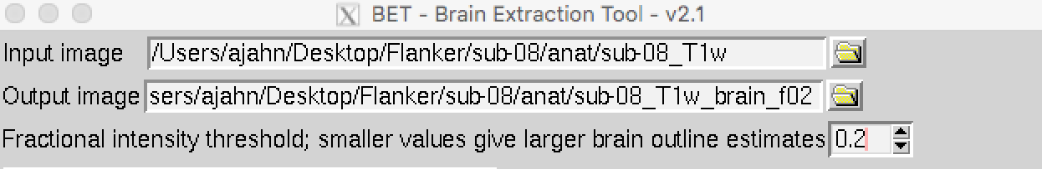

When it has finished, load the newest skullstripped image in FSLeyes. Click on the eye icon next to the original anatomical image, and also click on the eye icon next to the newest skullstripped image that we have just created. Note where more cortex has been preserved, especially in the frontal cortex and parietal cortex. You may also have noticed that more dura mater and bits of skull remain in this image. As a general rule, it is better to err on the side of leaving too much skull, as opposed to removing too much cortex - bits of skull here and there won’t cause future preprocessing steps to fail (such as normalization), but once cortex is removed, you cannot recover it.

## **Exercises**

1. Change the fractional intensity threshold to 0.1 and rerun BET, making sure to choose an appropriate output name to keep your files organized. View the result in FSLeyes. Repeat these steps with a fractional intensity threshold of 0.9. What do you notice? What seems to be a good threshold?
2. Experiment with different contrast colors for the overlay image in FSLeyes to see which one you like the best. Use the Zoom slider (next to the magnifying glass icon) to focus on a region you think hasn’t been stripped well. Take a photo of the montage (i.e., all three viewing panes) by clicking on the Camera icon in the toolbar above the montage.

## **Video**

To see a screencast demonstrating how to check your skullstripped image, click [here](https://youtu.be/VobRXk3ccNQ). This may help you with the exercises above.

[Previous](https://andysbrainbook.readthedocs.io/en/latest/fMRI_Short_Course/fMRI_04_Preprocessing.html)

[Next](https://andysbrainbook.readthedocs.io/en/latest/fMRI_Short_Course/Preprocessing/FEAT_GUI.html)